Outline of the Plans for a Community Garden in Addiscombe Railway Park
At the end of 2015 we asked local people via social media, emails to our members and community groups, a poster campaign, an online survey and a public meeting whether they would like to be involved in a community garden and events in Addiscombe Railway Park, and over 50 people said yes!
When we asked people what they would like to achieve with their community garden and events in Addiscombe Railway Park – here is what they told us:
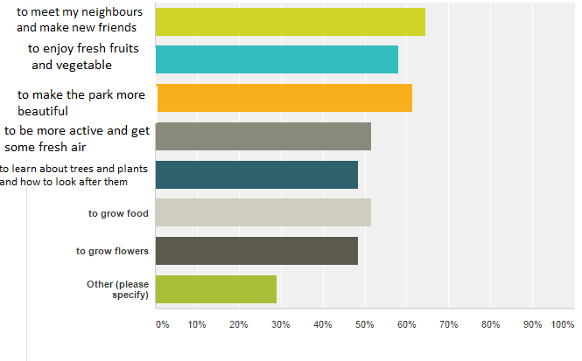
We also asked people what they would like to see in the garden and have summarised their answers here:
- Neighbours coming together and events
- To grow fresh produce
- Concerns over vandalism
- Activities for children
- Colour and beauty
- Improved safety
- Accessibility is important
- Trees, shrubs grasses and low maintenance plants, consideration to walkers, birds and dogs
- A sensory garden

So we applied for a grant and have secured funding to create a Community Garden within Addiscombe Railway Park and run some events where people can both connect with their neighbours and with nature, growing, trees, plants, flowers, fruits and vegetables.
We held a walkabout in the park on the 24th April 2016 to discuss the plans with The Conservation Volunteers (TCV), and publicised this event through our website, streetlife, facebook, twitter, emails to our mailing list and local community groups and organisations. We also put posters advertising the event in the park and flyered some of the local area including Amberley Grove, some of Morland Road, Capri Road and Windermere Road (although could not do all of Addiscombe as we didn’t have enough volunteers to help!)
TCV will build 4 raised beds over 2 days in June/July. Railway Park volunteers and local residents will be invited to take part. TCV will fill the beds with organic soil, with two beds at a heights of 0.675m and the remaining two beds at a height of 0.45m. The beds will be 1m by 1.9m in dimension. Please see the attached drawings for layout. Volunteers will build further beds from salvaged materials over time. Additional soil will be ordered at the same time as TCV order the soil to fill these additional beds. The beds will be arranged around a central focal point of a raised bed made by a volunteer and will include two dedicated crocus sativa (saffron) beds.
We have applied for and been granted separate funding for a community notice board which will have an opening clear front to display dates of workparties and events, planting schedule, outline of monthly tasks, contact details for how to get in touch and join in.
We will purchase a bench, please see the plans for the location. Beside the bench we will place of a piece of sculpture made and donated by a volunteer.
2 further compost bins will be built from pallets and chicken wire by our volunteers and located beside existing compost bins in the coal yard.
To ensure access for people with mobility problems we will level a gap of 100mm wide at the entrance – removing some the earth mound here. We have been advised by TCV that woodchip is suitable for wheelchairs, mobility scooters or buggies so will cover paths of 1m wide between the beds with this. TCV will order the woodchip and lay down as a path. We will leave a 2meter space between all of the beds so as there is manoeuvrability.
A local resident has requested that we leave a 2-3meter wild border between the garden and the North West perimeter fence, to maintain privacy of his property and reduce direct noise from the park. We will install a low cost fence of wooden stakes and orange string (similar to what is in the orchard) to protect this area. We will request through the council that the contractors do not mow or strim this area between the garden and the perimeter fence. TCV will apply for funding to purchase some hedging plants that the railway park volunteers can plant in this area, as well as check with Mieke Weiser on whether they can advise low cost suppliers of blackthorne, hawthorne, wildroses etc. Pyrocanthus has also been suggested.
We need to be realistic about what we can achieve based on how many people are actively involved. If we have enough manpower we aim to also plant a ‘sensory bank’ beside the garden on an existing bank that we will replenish with fresh soil and plant low maintenance shrubs and grasses that appeal to all senses – sound, smell, touch, sight, taste. In the future we will aim to site some child friendly activities near the garden, however planning, funding and installation will need to be addressed separately.
We will use organic gardening methods, crop rotation, companion planting, green manures, manual weeding, encouragement of predators through planting and leaving wild spaces surrounding the garden.
We will draw up an outline of tasks to be undertaken on a month by month basis in the garden. Over the summer we will draw up a rota for volunteers to take it in turns watering the orchard, raised beds and any other young trees in the park.
Participants will meet for monthly half day gardening sessions on the 2nd Sunday of every month as well as at least 25 additional sessions to coincide with busy times such as harvests and planting.
We will need to keep the buddlea, willow and brambled trimmed short between the main path through the centre of the park and the garden.
As well as gardening sessions we will also run at least 4 free community events within the park to coincide with national/local events. These will be opportunities to join in with gardening, enjoy guided tours, socialise, meet new people and have fun. At these events we will explore additional different ways for more local people and visitors to be involved and gather feedback on what they feel they would benefit from within the park.
4 free community events will be:
Big Lunch 12th June – Bring and Share Picnic, Park Friends Gazebo with park info, games, planting activities in the community garden, tours of the park, children’s wildlife trail
The Croydon Heritage Festival – 19th June ‘Now and Then’ Tour, Park Friends Gazebo with park info, planting activities in the community garden
Love Parks Week 17th July - Bring and Share Picnic, Park Friends Gazebo with park info, games, planting activities in the community garden, tours of the park
Apple Day on the 25th September 2016 - Bring and Share Picnic, Park Friends Gazebo with park info, apple cake, cider, games, apple bobbing, apple peeling, tours of the park
To help advertise the events and the garden we will print flyers and posters to be displayed by local businesses and community groups, as well as purchasing 12 banners to hang in the entrances of the park on our workdays, gardening sessions and event days. We will ask goodgym to help us with flyering. We will also advertise via our mailing list, website and social media and continue to contact community groups, schools, businesses etc directly.
We need to evidence that our activities have had an impact so starting from May 2016 we will ask everyone attending a gardening session or activity in the park to complete a questionnaire, collecting an email as part of this questionnaire. We will repeat this questionnaire May 2017, emailing everyone that took part previously to try to gain a comparison from the same group of people.
Plan of Community Garden


